

**Year 12 Human Biology**

**Test: Human Evolution**

|  |
| --- |
| Name: |
| Teacher: |

|  |  |  |
| --- | --- | --- |
|  | Marks Received | Marks Available |
| Multiple Choice |  | 20 |
| Short Answer |  | 25 |
| Extended Answer |  | 10 |
| Total |  | 55 |

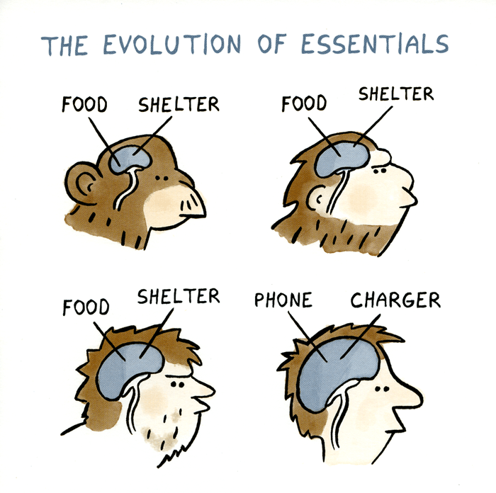Weighting: 5%

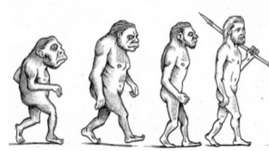





**SECTION A – MULTIPLE CHOICE**

1. Which one of the following is **not**  a likely part of human evolution from the early hominins?
   1. Increase in brain size
   2. Shift in the position of the foramen magnum
   3. Development of binocular vision
   4. Reduction in size of canine teeth

The next three questions are based on the following data:

Studies of four skeletons from different excavation in the same general region of Africa yielded the following data:

|  |  |  |  |
| --- | --- | --- | --- |
| **Skeleton Number** | **Cranial Capacity (cc)** | **Relative length of arms and legs** | **Artefacts found with skeletons** |
| 1. | 400 | Arms longer than legs | Arrow |
| 2. | 1300 | Arms shorter than legs | None |
| 3. | 600 | Arms the same length as legs | None |
| 4. | 1000 | Arms shorter than legs | Stone Axe |

1. The skeleton most like that of modern humans is:
   1. 1
   2. 2
   3. 3
   4. 4
2. The individual which probably walked most erect are:
   1. 1 & 2
   2. 1 & 3
   3. 1 & 4
   4. 2 & 4
3. The presence of an arrow near skeleton 1 is best interpreted by saying the individual:
   1. Was killed by an arrow
   2. Used fire for cooking
   3. Could make arrowheads
   4. Lived at a time when tools were used
4. A commentator on the radio was overheard saying that the samples of stone tools found at a site in East Africa associated with the earliest Hominin fossils has been sent for radiocarbon dating.

What is wrong with the commentator’s statement?

* 1. The fossils in East Africa are in deposits containing high levels of radioactive materials so this dating technique doesn’t work.
  2. Radiocarbon dating can only be carried out on organic materials not stone tools
  3. The amount of carbon breakdown is not enough to be detected by even the most sensitive instruments.
  4. Radiocarbon dating is only useful on materials that are older than the fossils found at this site.

1. One of the last marked physical characteristics to evolve in *Homo sapiens*  has been the:
   1. Chin
   2. Upright posture
   3. Arched foot
   4. Broad pelvis
2. Which one of the following characteristics would **not** be used to decide whether a primate should be classified as a hominin rather than an ape?
   1. Number of incisor teeth
   2. Arches formed by the bones of the foot and bipedalism
   3. Shape of the dental arcade and body hair
   4. Relative size of canine teeth and erect posture
3. Potassium argon dating may be used to determine the:
   1. Absolute age of volcanic rocks
   2. The relative age of volcanic rocks
   3. The relative age of fossil bones
   4. The absolute age of fossil bones
4. The fossil primate skull was found in a cave near Johannesburg, South Africa. Some details of the discovery are set out below:
5. Estimated age of rock in which skull was found approximately 2 million years
6. Description of skull – brain capacity about 600cc rounded cranium. No bony crest for attachment of neck muscles. Position of hole for entry of spinal cord suggests that animal walked upright. Jaw rounded rather than U-shaped. Canine teeth small and relatively inconspicuous.
7. Tool embedded in rock of the same age were found a short distance from the skull.

This evidence suggests that the fossil could be the remains of:

* 1. Neanderthals
  2. *Homo erectus*
  3. *Australopithecus*
  4. *Homo habilis*

1. In a dig in an East African cave an anthropologist found and accient fire-place that contained the fire-blackened fossil bones of an extinct species of antelope. Nearby at the same level some stone tools were found that had been shaped on two faces to form an axe handle. The occupier of the cave was most likely:
   1. *Australopithecus afarensis*
   2. *Homo habilis*
   3. *Homo neanderthalensis*
   4. *Homo erectus*
2. The Neanderthal DNA was extracted from a fossil that was approximately 25 000 years old. A method used to determine the absolute age of this fossil could be:
   1. Potassium-argon dating
   2. Stratigraphy
   3. Dendrochronology
   4. Carbon-14 dating

|  |  |  |
| --- | --- | --- |
| **Hominin** | **Cranial Capacity** | **Forehead** |
| 1 | 850cc | Slight |
| 2 | 1450cc | Often receding |
| 3 | 1050cc | Slight |
| 4 | 1400cc | Rounded |

The data presented above indicate that:

1. Hominin 1 is *Homo sapien* and hominin 2 is *Homo erectus*
2. Hominin 1 is *Homo habilis* and hominin 3 is *Homo sapien*
3. Hominin 3 is *Homo erectus* and hominin 4 is early Homo
4. Hominin 2 is *Homo neanderthalensis* and hominin 3 is *Homo erectus*

**The next two questions relate to the diagram below.**



1. Which of the strata locations shown above contains the oldest layer at its surface?
   1. A
   2. B
   3. C
   4. D
2. When referring to the diagrams above, which statement is correct?
   1. O is younger than H
   2. D is older than M
   3. A is the same age as J
   4. P is younger than F
3. The principle of superposition is that:
   1. Lighter rocks rest on top of heavy rocks
   2. Younger rocks are found on top of older rocks
   3. Fossils are found in sedimentary rocks
   4. Older rocks are found near the surfaces due to earthquake activity
4. The table below shows the number of nucleotide differences between a section of mitochondrial DNA is modern humans, chimpanzees and a Neanderthal fossil.

|  |  |  |  |  |
| --- | --- | --- | --- | --- |
|  | **Neanderthal** | **Chimpanzee 2** | **Chimpanzee 1** | **Human 2** |
| **Human 1** | 21 | 76 | 77 | 14 |
| **Human 2** | 27 | 79 | 80 | - |
| **Chimpanzee 1** | 72 | 22 | - | - |
| **Chimpanzee 2** | 70 | - | - | - |
| **Neanderthal** | - | - | - | - |

Based on this data in the table, which individual is related most closely to the Neanderthal?

1. Human 1
2. Human 2
3. Chimpanzee 1
4. Chimpanzee 2

**Question 17 refers to the table below:**

|  |  |  |
| --- | --- | --- |
|  | **Presence of Diastema** | **Amount of wear on opposing (occlusal) surfaces of molar teeth** |
| **A** | Some individuals | Extreme |
| **B** | No individuals | Moderate to extreme |
| **C** | All individuals | Very little |

1. Dental features ca be used to distinguish various hominins. Which of the following correctly identifies A, B and C?
   1. A – Chimpanzee, B – *Auatralopithecus,* C – Modern Human
   2. A – *Auatralopithecus,* B – Chimpanzee,C – Modern Human
   3. A – *Auatralopithecus,* B – Modern Human,C – Chimpanzee
   4. A – Modern Human*,* B – Chimpanzee,C –*Auatralopithecus*

**The next question refers to the diagram below that depicts primate skulls.**



1. Which of the following would be the most likely evolutionary sequence towards *Homo sapiens*?
   1. 3, 4, 2, 1
   2. 3, 2, 4, 1
   3. 4, 3, 2, 1
   4. 4, 2, 3, 1

**The next question refers to the graph below:**



Radiocarbon (C-14) dating in a commonly used procedure to estimate the age of some fossils. The graph below is a typical decay curve for C-14.

1. Using the graph only, the approximate age of a plant fossil that contains only one quarter of the carbon-14 that is normally found in newly formed plant tissue is estimated to be:
   1. Less than 5000 years
   2. 11 000 years
   3. Less than 10 000 years
   4. About 15 000 years
2. During a fossil dig at four separate locations various hearths were uncovered. Artefacts were removed from each site and carbon-14 dating was carried out at each site. The results are shown below. Which of the hearths would be the oldest?

|  |  |  |  |  |
| --- | --- | --- | --- | --- |
|  | **Hearth** | **Depth found (m)** | **C14:C12 Content** | **Artefact** |
| a. | 1 | 1.6 | 1:1 trillion | Bone point |
| b. | 2 | 1.9 | 2:1 trillion | Carved horn |
| c. | 3 | 2 | 3:1 trillion | Stone flake |
| d. | 4 | 3.1 | 4:1 trillion | Stone axe |

**SECTION B – SHORT ANSWER**

1. Millions of mammoth remains have been uncovered in Siberia including many tusks that were used in the past for the ivory in piano keyboards. State two conditions that would have led to the excellent state of preservation of these fossils. (2 marks)

*Fast burial*

*Exclusion of bacteria for decomposition due to cold*

*Exclusion of bacteria for decomposition due to oxygen*

1. The diagram below shows three lower jaw / mandible outlines.



* 1. Which of the three jaws is that of an apes; A, B or C? (1 mark)

*C*

* 1. Give two reasons for your answer. (2 marks)

*Large canines and Diastema*

*Square shaped dental arcade*

* 1. Which jaw is most likely to be an Australopithecine? Why?

(2 marks)

*B*

* *Its dental arcade is not square like the ape but not completely parabolic like the human.*
* *Has a diastema like the ape but no canines.*
* *Larger teeth than humans*

1. Palaeontologists use a variety of methods to date the fossils or artefacts they find. One such method, potassium-argon dating, is based on the breakdown of potassium-40 to argon-40. Another method is carbon-14 dating.
   1. Each method of dating can only be used in certain circumstances. State two limitations for the use of carbon-14 dating. (2 marks)

* *Can only be used for objects up to 60000 /70000 years*
* *Objects must contain carbon / be organic.*
* *Requires at least 3 grams of material*
* *The ratio of C14 to C12 over time may have changed.*
  1. Index fossils are a useful tool to palaeontologists. What are index fossils and how are they used in dating? (2 marks)

*Index fossils are fossils which occurred in a particular time period and are widespread.(1)*

*They are used in stratigraphy (1)to identify that particular time period(1)*

26.

The pictures above represent a particular tool culture.

a. Name this tool culture. Explain your choice. (2 marks)

*Oldowan*

*It is a riverstone which has had one side chipped to form a blade.*

b. Which Homo species is responsible for their production. (1 mark)

*Homo habilis*

c. Name **one** other tool culture and describe how the materials used affects the manufacturing technique. (2 marks)

* *Achulian – tools made from rocks*
* *Were shaped on both sides – bifacial*
* *Mousterian – tools made from flint*
* *Large chips were flaked off and shaped on one side.*
* *Upper Paleolithic – other materials like bone, ivory and antler were used*
* *Could be made in to finer and more varied tool.s*

d How has the use of tools contributed to the trend of increasing brain capacity of the *Homo* genus (4 marks)

* *Tool use allows meat to be cut into smaller pieces*
* *Change in diet to include more meat*
* *Protein/ fat allows for greater brain growth*
* *Hunting provides more meat*
* *Tool use leads to more complex thought/ reasoning/problem solving*
* *Frontal lobe growth*

**SECTION C – EXTENDED ANSWER**

27. The lower limb of *Homo sapiens* show many adaptations to bipedalism when compared to the quadrupedal apes. Describe **five** of these differences and explain how each enables the striding gait of *Homo sapiens.*

(10 marks)

Extended answer

|  |  |  |  |
| --- | --- | --- | --- |
| Feature | Humans | Apes | Striding gait |
| Carrying Angle | * Femurs angle in toward knees | * Legs straight down from hips * No carrying angle | * Allows one leg in front of the other * No swaying when walking * Stability * Less energy |
| Knees | * Double hinge joint * Stronger/larger on outer side * Ligaments to support outside | * Smaller / weaker single knee joint | * Supports weight when stepping * Resists bending backwards * Prevents knee collapsing on striding * Prevents hyperextension * Less energy needed in striding |
| Legs | * Legs longer than arms | * Arms longer than legs | * Allows for longer stride/larger steps * Less energy * Centre of gravity lower in body |
| Heel | * Calcaneus bone larger forms bigger heel | * Smaller heel | * First point of contact / stability on stepping * Allows for start of rolling step |
| Toes (2 possibilities) | * Parallel / aligned * Large toe not opposable | * Toes not aligned * Opposable big toe | * Push off on stepping * Rigid foot for weight bearing / balance |
| Arches | * Both longitudinal and transverse arch | * Only longitudinal arch | * Balance * Allow rolling step / heel – foot – big toe |